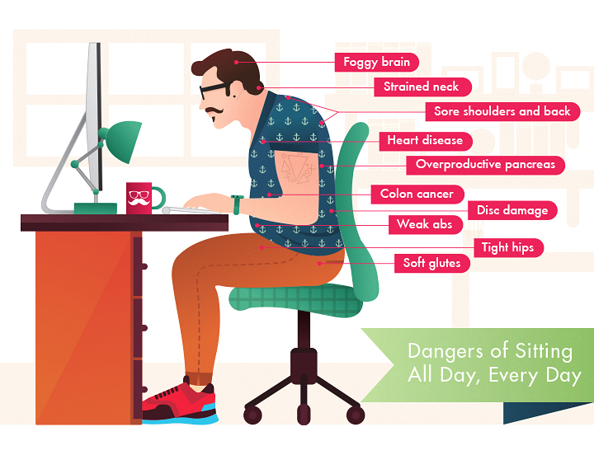
Undo Your Desk Sitting Workshop
Bring Ambika to your office for a one hour class on how to undo the potentially debilitating effects of sitting at a desk and working on a computer all day. Even if you do not have any chronic issues now, these easy techniques can help prevent future pain and missed work days!
Ambika uses her knowledge as a registered yoga teacher and physical therapist assistant to educate people through lecture, demonstration and participation, on ways to acquire and maintain healthy alignment for improved overall health.
Email for a quote to bring Ambika to your office or other event space for a 1hr workshop or more.
Contact info and more at https://www.yogambika.com/ambika-for-hire.

